Welcome, Students and Parents, to your Go Math! Resources on ThinkCentral.com!

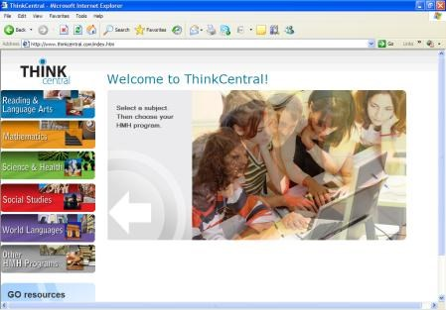
Welcome to Think Central, a website where you can access your Go Math! textbooks and fun interactive activities! Go to http://www.thinkcentral.com/index.htm.

Click on “Mathematics” from the list on the left of the screen; then click your text, “Go Math” toward the top right of the screen.

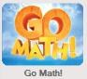
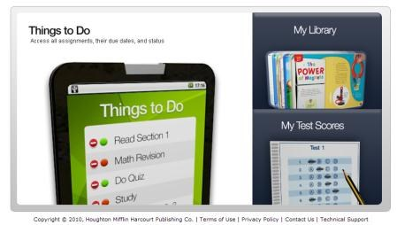
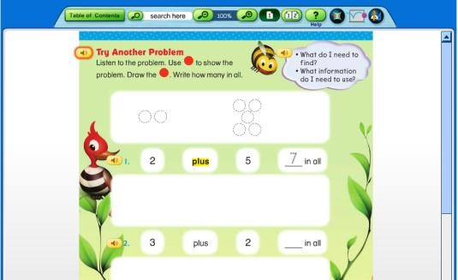
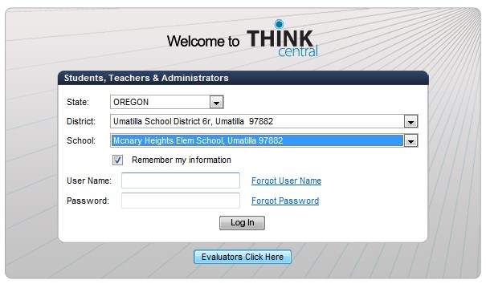
Use the dropdown boxes to select your state, district, and school, as in the illustration on the right. You may
want to click “Remember My Organization.”

Your teacher has assigned you this username ___________________ and password ___________________.

If your computer asks if you want to allow pop-ups, select Always Allow Pop-Up From This Site.

Once you are in the system, you simply click on Library to access your Student Edition (it may take awhile to load). Note you can go to any page in your book, and access iTools (eManipulatives), Animated Math, etc.

You can also access some printable resources in the Student Library by clicking on items such as the Go Math! Standards Practice Book. Don’t forget to investigate the Real World Videos!

“Things to Do” will list current assignments if your teacher is creating assignments.

“My Test Scores” will list scores of online tests IF your class is taking online assessments.
cpilcher 8/2/2012

